Implementation and Testing for

Sheltr

Prepared By:
Gabriela Germán Toledo,
Miguel A. Hernández Betancourt,
Ian M. Pérez López,
Sebastián A. Ramírez González

University of Puerto Rico, Rio Piedras Campus
V0.0
December 10, 2025

Table of Contents
1 Introduction 1
1.1 Purpose 1
1.2 Document Conventions 1
1.3 Intended Audience and Reading Suggestions 1
2 Implementation Details 1
2.1 Technical Specifications 1
2.2 How to Run the Application 1
2.3 Credentials 1
3 Test Cases 1
3.1 Test Case – Feature A 2
3.2 Test Case – Feature B 2
4 Bugs and Fixes 2
5 References 2

Version History

Date | Author | Version | Description
11/13/2025 | John Doe | 0.1 | Initial draft.

Introduction

Purpose
This document describes the implementation details, technical specifications, and testing procedures for Sheltr, an emergency shelter management application. It covers how to run the application, access credentials, test cases for core functionality, and documented bugs with their fixes.

Document Conventions
Key terms: User - any registered account holder; Volunteer - a user who can be assigned tasks at shelters; Manager - a user with administrative privileges; Task - a work assignment at a shelter; Shelter - an emergency shelter location; Emergency - a disaster event requiring shelter activation. Bold text indicates section headings and important terms. Italics are used for emphasis and technical terms like API endpoints.

Intended Audience and Reading Suggestions
This document is intended for: (1) Developers who need to understand the technical implementation - should read sections 2.1, 2.2, and 3 in full; (2) QA testers who need to verify functionality - should focus on section 3 (Test Cases); (3) System administrators who need to deploy the application - should read sections 2.2 and 2.3 for setup and credentials; (4) Project stakeholders reviewing technical progress - should read sections 1 and 4 for overview and known issues.

Implementation Details
This section provides technical specifications for the Sheltr application, including hosting details, technology stack, setup instructions, and access credentials.

Technical Specifications
The application runs locally via Docker or Python virtual environment. Components: Flask web application (Python 3.12+) serving on port 5001, SQLite database stored in instance/sheltr.sqlite, Bootstrap 5 frontend via Jinja2 templates. Technologies: Flask 3.1.0 for web framework, PyJWT 2.10.1 for authentication tokens, Werkzeug 3.1.3 for password hashing, Gunicorn 23.0.0 for production WSGI server. The application can be containerized using Docker with the provided docker-compose.yml configuration.

How to Run the Application
1. Ensure Python 3.12+ is installed. 2. Clone or download the Sheltr repository. 3. Navigate to the project directory. 4. Run 'python ignition.py' to start with Docker (recommended) or 'python ignition.py --local' for local venv mode. 5. Open a web browser and navigate to http://localhost:5001. 6. Register a new account or use the test credentials provided below.

Credentials
Application URL: http://localhost:5001. Test Credentials - Volunteer accounts: volunteer1 (password: Volunteer1!), volunteer2 (password: Volunteer2!), volunteer3 (password: Volunteer3!). Manager accounts: manager1 (password: Manager1!), manager2 (password: Manager2!). Managers have access to the admin panel at /admin for managing shelters, tasks, and emergencies.

Test Cases (At least 5)
This section documents the manual test cases performed to verify core functionality. The application also has 309 automated tests with 100% code coverage using pytest.

Test Case – User Authentication
Test Case: User Registration and Login. Step 1: Navigate to /auth/register. Expected: Registration form displays. Obtained: Form displayed correctly. Step 2: Enter valid username, email, and password meeting requirements (8+ chars, uppercase, number, special char). Expected: Account created, redirected to login. Obtained: Success message shown, redirected to login page. Step 3: Navigate to /auth/login and enter credentials. Expected: Login succeeds, JWT cookie set. Obtained: Successfully logged in, redirected to dashboard. Step 4: Click logout button. Expected: Session cleared, redirected to login. Obtained: Logged out successfully. Step 5: Attempt login with wrong password. Expected: Error message displayed. Obtained: 'Incorrect password' error shown.

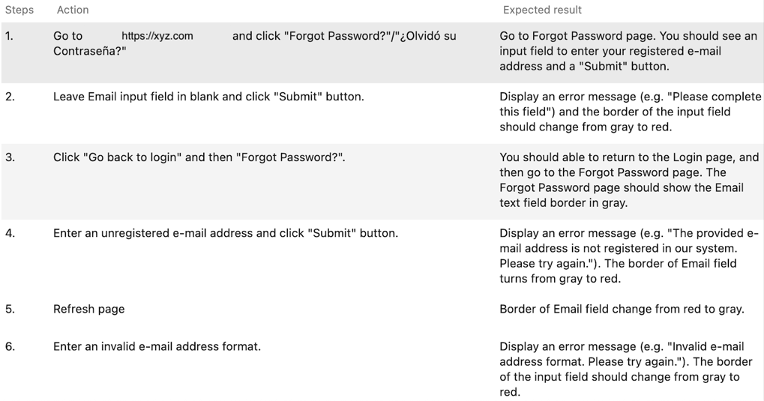

Test Case – Task Status Management
Test Case: Task Status Management. Step 1: Log in as volunteer1. Expected: Dashboard displays. Obtained: Dashboard shown with user greeting. Step 2: Navigate to /tasks. Expected: Assigned tasks displayed. Obtained: Task list shown with pending tasks. Step 3: Change task status from 'pending' to 'in_progress'. Expected: Status updates via AJAX. Obtained: Status changed without page reload. Step 4: Change task status from 'in_progress' to 'finished'. Expected: Completion timestamp recorded. Obtained: Task marked finished with timestamp. Step 5: Filter tasks by status. Expected: Only matching tasks shown. Obtained: Filter works correctly.

Test Case – Shelter Browsing
Test Case: Shelter Browsing. Step 1: Log in as volunteer1 and navigate to /shelters. Expected: List of shelters displays. Obtained: All shelters shown with names and locations. Step 2: Click on a shelter name. Expected: Shelter detail page opens. Obtained: Detail page shows shelter information and tasks. Step 3: View tasks associated with shelter. Expected: Tasks list displays with status. Obtained: Tasks shown with pending/in_progress/finished status. Step 4: Check task details. Expected: Task description visible. Obtained: Full task details displayed. Step 5: Navigate back to shelter list. Expected: Return to shelter directory. Obtained: Successfully returned to shelter list.

Test Case – Manager Task Creation
Test Case: Manager Task Creation. Step 1: Log in as manager1 and navigate to /admin/shelters. Expected: Admin shelter list displays. Obtained: All shelters shown with management options. Step 2: Select a shelter and click 'Add Task'. Expected: Task creation form appears. Obtained: Form displayed with name, description, volunteer assignment fields. Step 3: Fill in task details and submit. Expected: Task created successfully. Obtained: Success message shown, task appears in list. Step 4: Edit the created task. Expected: Edit form populates with task data. Obtained: Form shows existing task information. Step 5: Assign task to volunteer2. Expected: Assignment saved. Obtained: Task now shows volunteer2 as assignee.

Test Case – Profile Management
Test Case: Profile Management. Step 1: Log in and navigate to /profile. Expected: Profile page displays user information. Obtained: Name, email, phone, city shown correctly. Step 2: Click 'Edit Profile' and update phone number. Expected: Edit form allows changes. Obtained: Phone field is editable. Step 3: Save profile changes. Expected: Changes persisted to database. Obtained: Success message shown, new phone number displayed. Step 4: Navigate to 'Change Password'. Expected: Password change form appears. Obtained: Form with current password and new password fields shown. Step 5: Enter current password and valid new password, then submit. Expected: Password updated successfully. Obtained: Success message, can log in with new password.

Bugs and Fixes
1. Bug: JWT token not refreshing before expiry. Fix: Added /auth/refresh endpoint that generates new token if expiring within 2 hours. 2. Bug: Password validation allowing weak passwords. Fix: Implemented validation requiring 8+ characters with uppercase, number, and special character. 3. Bug: Task status not persisting after page reload. Fix: Added proper database commit after status update in tasks.py. 4. Bug: Unauthorized users accessing admin routes. Fix: Added @manager_required decorator to all admin endpoints. 5. Bug: SQL injection vulnerability in user queries. Fix: Converted all queries to use parameterized statements with sqlite3 prepared statements.

References
Flask Documentation: https://flask.palletsprojects.com/. PyJWT Documentation: https://pyjwt.readthedocs.io/. Bootstrap 5 Documentation: https://getbootstrap.com/docs/5.0/. SQLite Documentation: https://www.sqlite.org/docs.html.

